**2019 OSSA accomplishments**

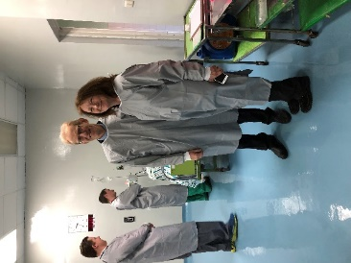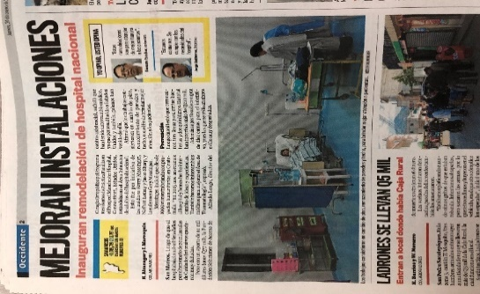 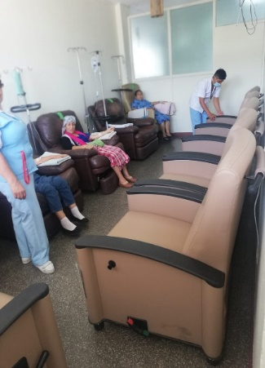  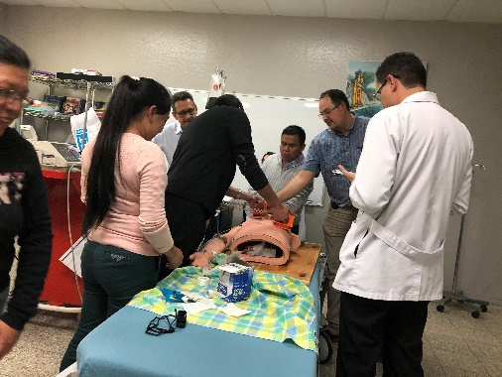

Shipped equipment from Windham and Manchester Hospitals to Cancer Hospital + Hospital San Marcos

OSSA/Yuri Dominguez/Hartford Hospital- Military, private hospital CESI ACLS course, first in San Marcos

OSSA and Manchester Family Practice residents sponsor refurbished ICU room

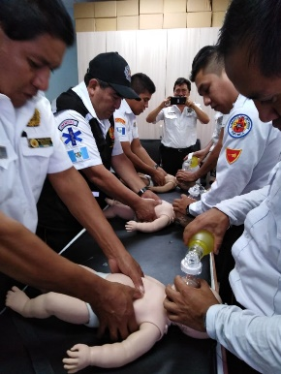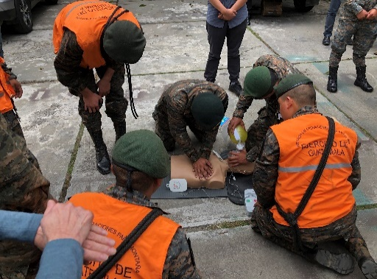 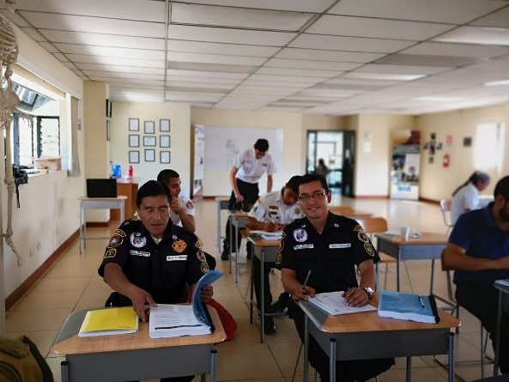

Support advanced Trauma training for Firefighter educators

OSSA/Dr Tereta teach CPR classes to Hospital staff, Firefighters, Military, private hospitals, first in San Marcos

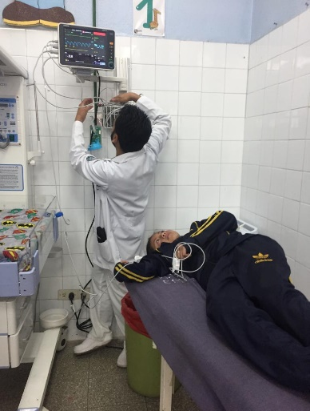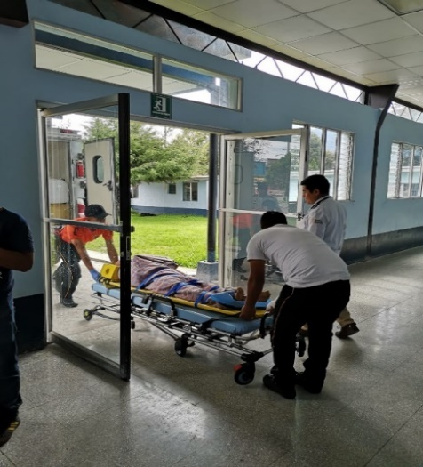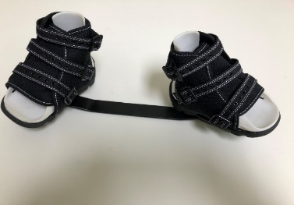

OSSA+Manchester Family Practice donated 3vital sign monitors with bases, EKG, and BP cuffs to San Marcos Hospital

Improved First Responder care/triage after training

OSSA is Guatemala distributor of Iowa Brace for Clubfoot

Support first resident doctor run Clubfoot Clinic

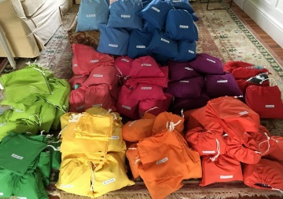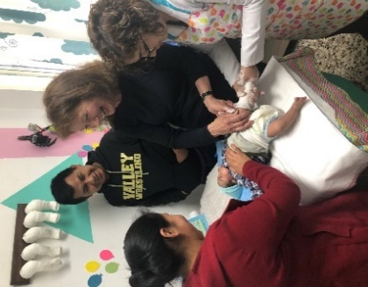

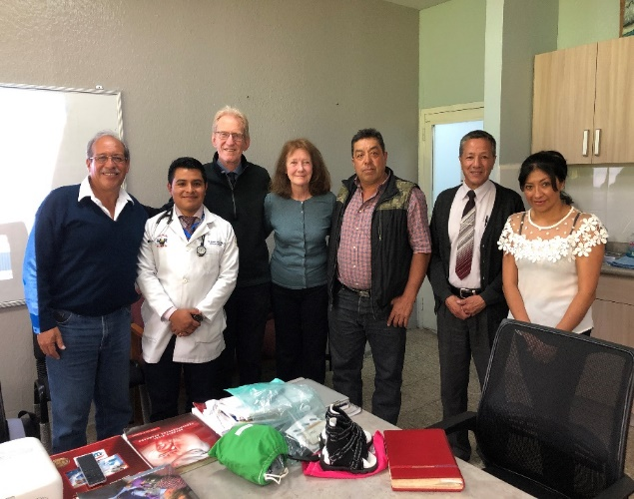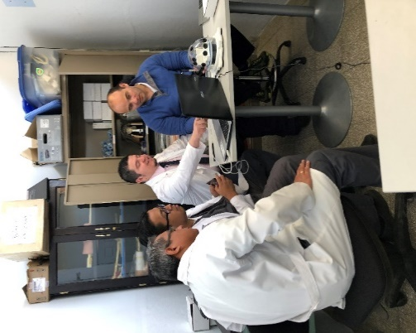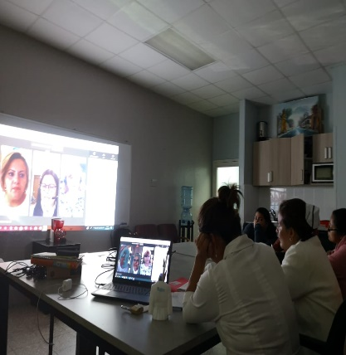

Ongoing communication with Senator Julio Longo, incoming San Marcos Mayor Mr. Willy Suarez, and San Pedro incoming Mayor Dr. Juan Eliezar

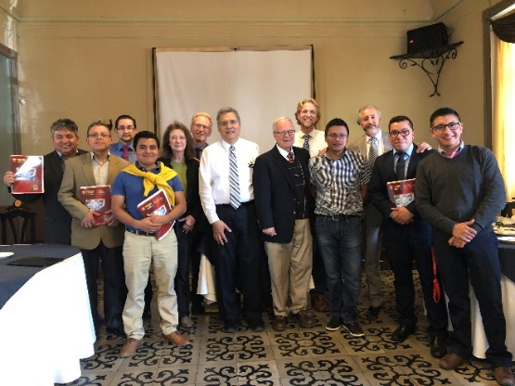

Sponsor Dr Ramazzini to teach arthroscopy to Trauma residents

OSSA sponsored Nursing international webinars

SponsorTEAM Trauma Evaluation And Management Course

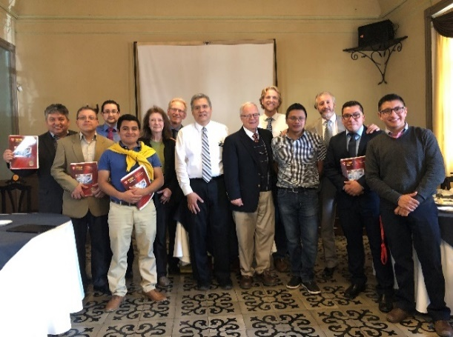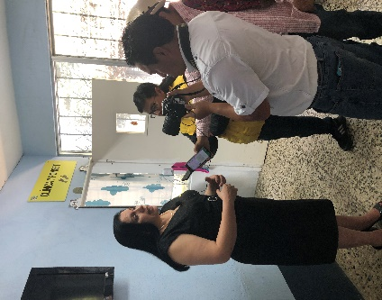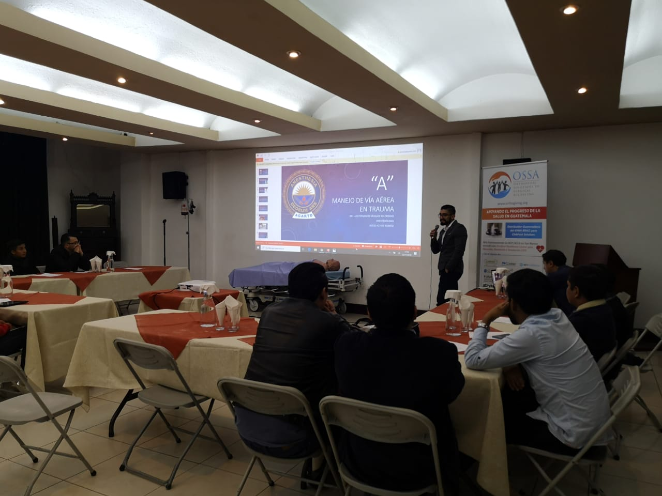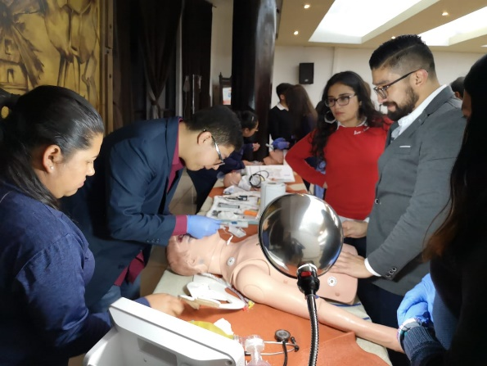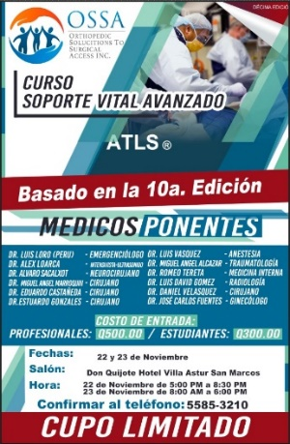

Sponsor TEAM Trauma Evaluation And Management Course

First OSSA Series of Specialty Lectures with Dra Ana Zambrano President of Ponseti International Guatemala- Treatment of Clubfoot; And Grand Opening of San Marcos Public Hospital Resident-run Clubfoot Clinic

OSSA sponsored first ATLS course in Guatemala

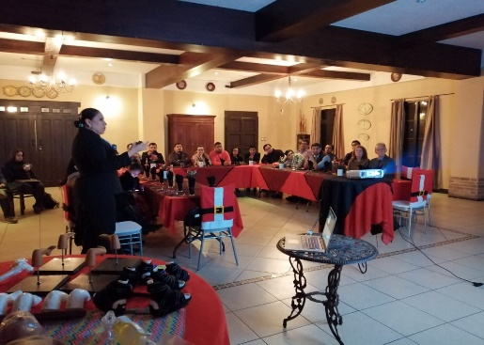

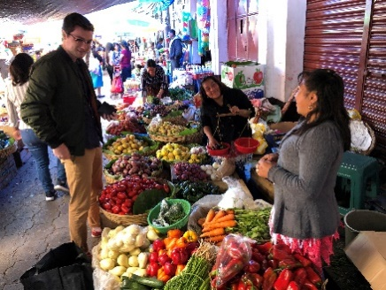

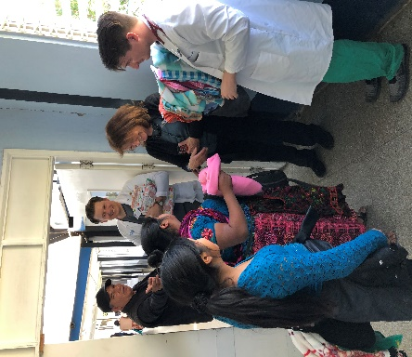 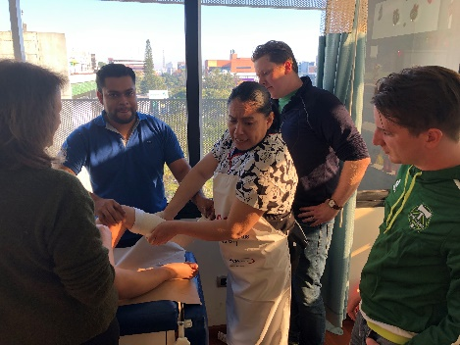

Spencer Abel assists OSSA with social networking and Connecticut fundraiser

Manchester Family Practice Drs Sharp and Lemay visit San Marcos Public Hospital and Dra Zambrano’s office in Guatemala City

