OSSA 2020 review
December 2019-Ponseti Clubfoot Clinic -December 2019 had celebration and grand opening of HNSM Ponseti Clinic a day after an OSSA Lecture series talk in San Marcos on Treating Clubfoot by Dra. Ana Zambrano, a vital consultant for OSSA from Guatemala City. This was the first Orthopedic resident run Clubfoot Clinic in Guatemala. Also, several workshops held for the residents.
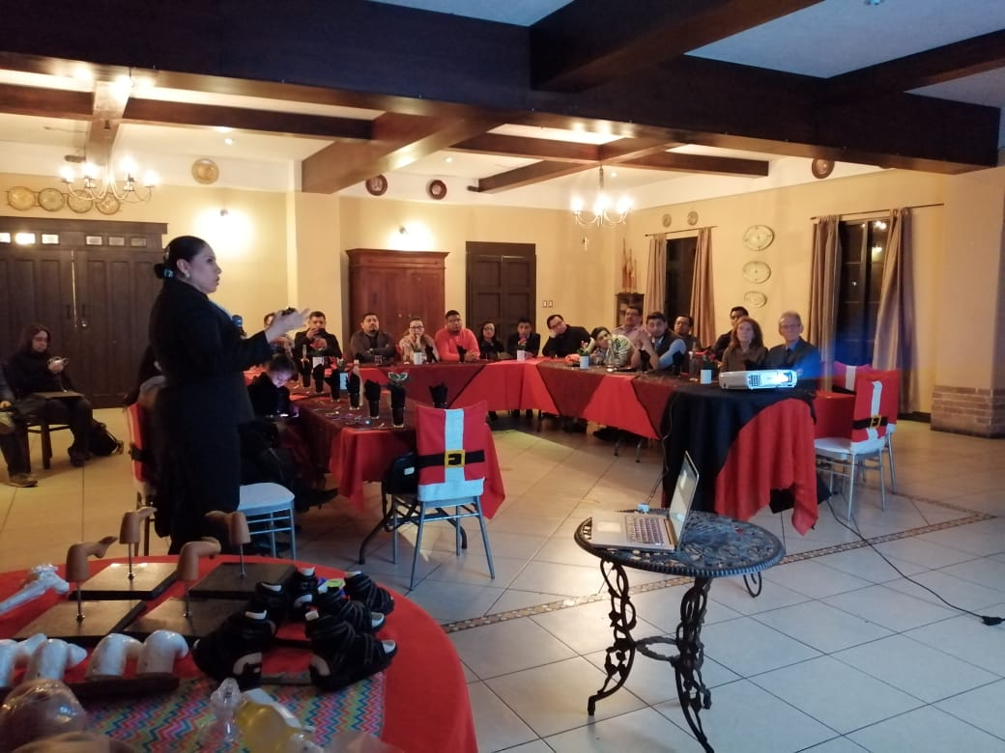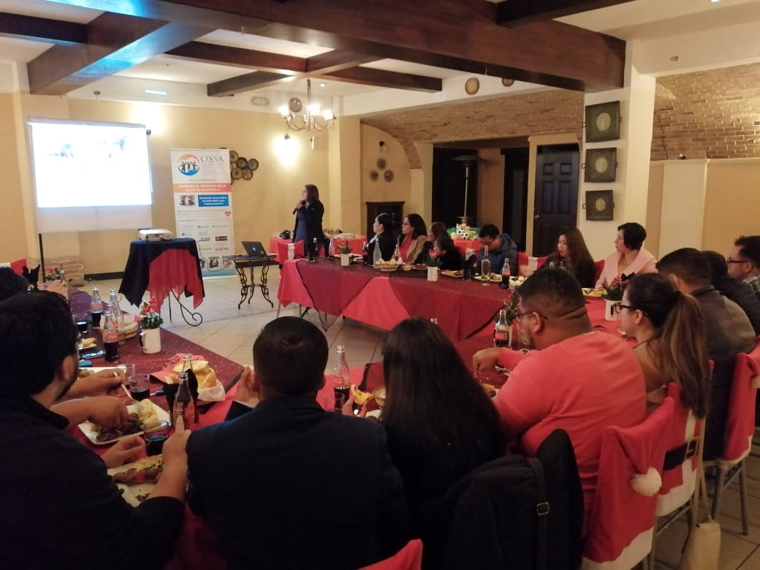
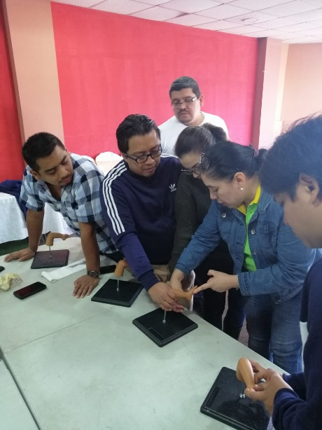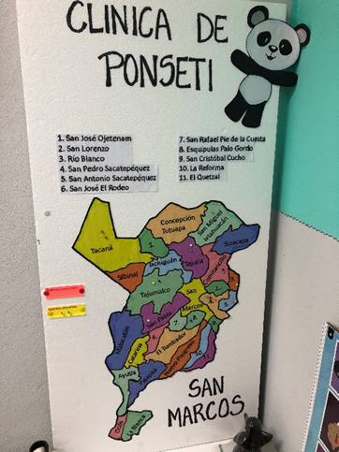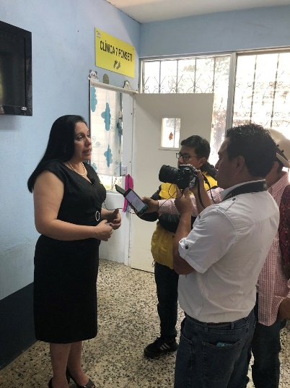
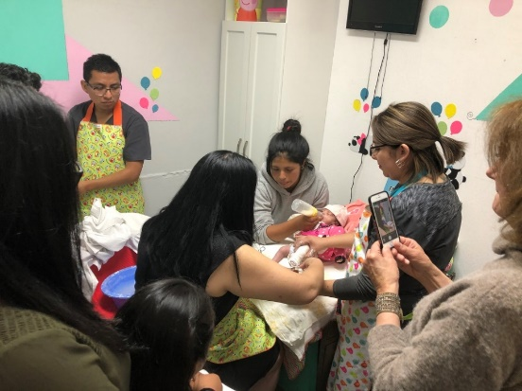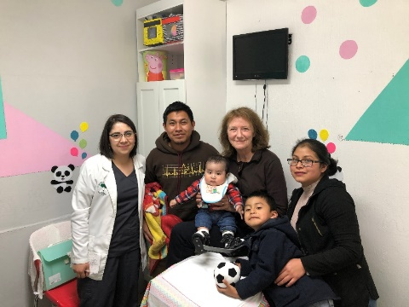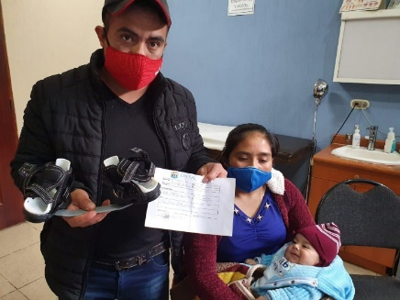

P2
Clinic had difficulty seeing patients after Covid restricted HNSM access to elective outpatient care.
January 2020-OSSA moved into new OSSA office near HNSM while still teaching different medical professionals in the OSSA office in HNSM. And when Lucky Orozco moved to Guatemala City OSSA hired Mr. Miguel Angel Aguilar to be the new OSSA Administrator and hired Dra Guadalupe Lupita de Leon for part-time medical education coordination and office administration. The extra space allowed for group education starting with CPR classes until the Coronavirus pandemic stopped group sessions so OSSA has improvised with its online Lecture Series coordinated by Dr. Romeo Tereta OSSA Medical Administrator. And Erick Garcia is OSSA’s Projects and Sports Manager, Walter Ardiano is Project Consultant, and Edwina,Wellington,Fernanda,Edelin Ardiano-OSSA support team.
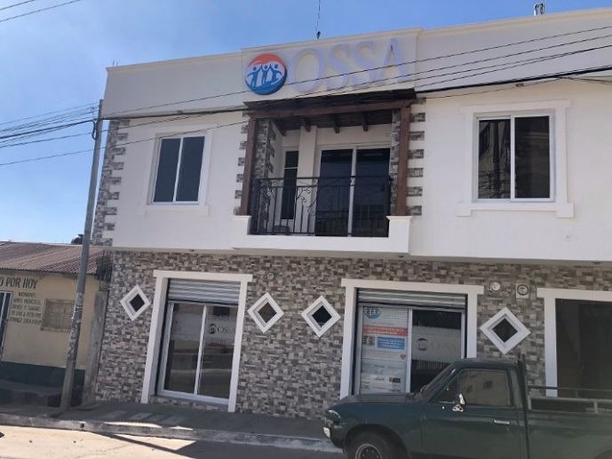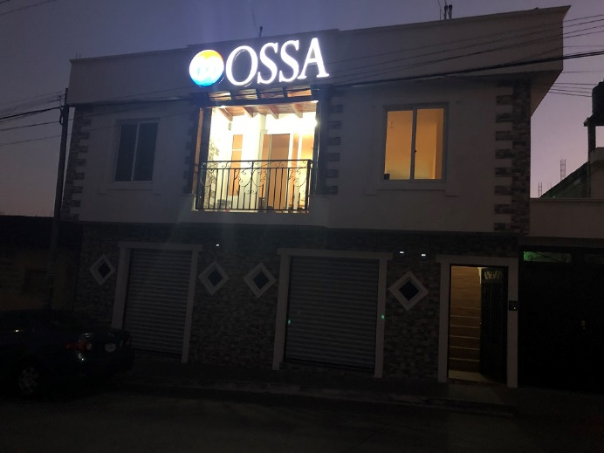
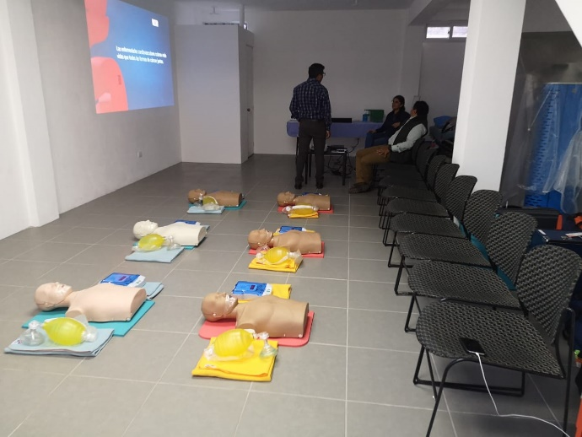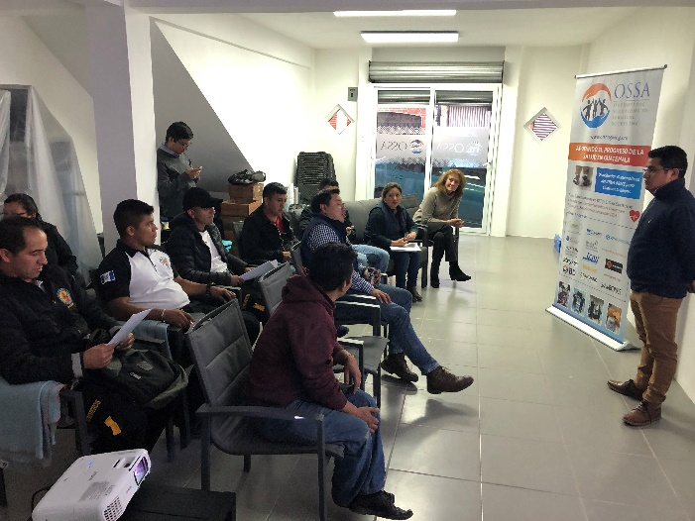

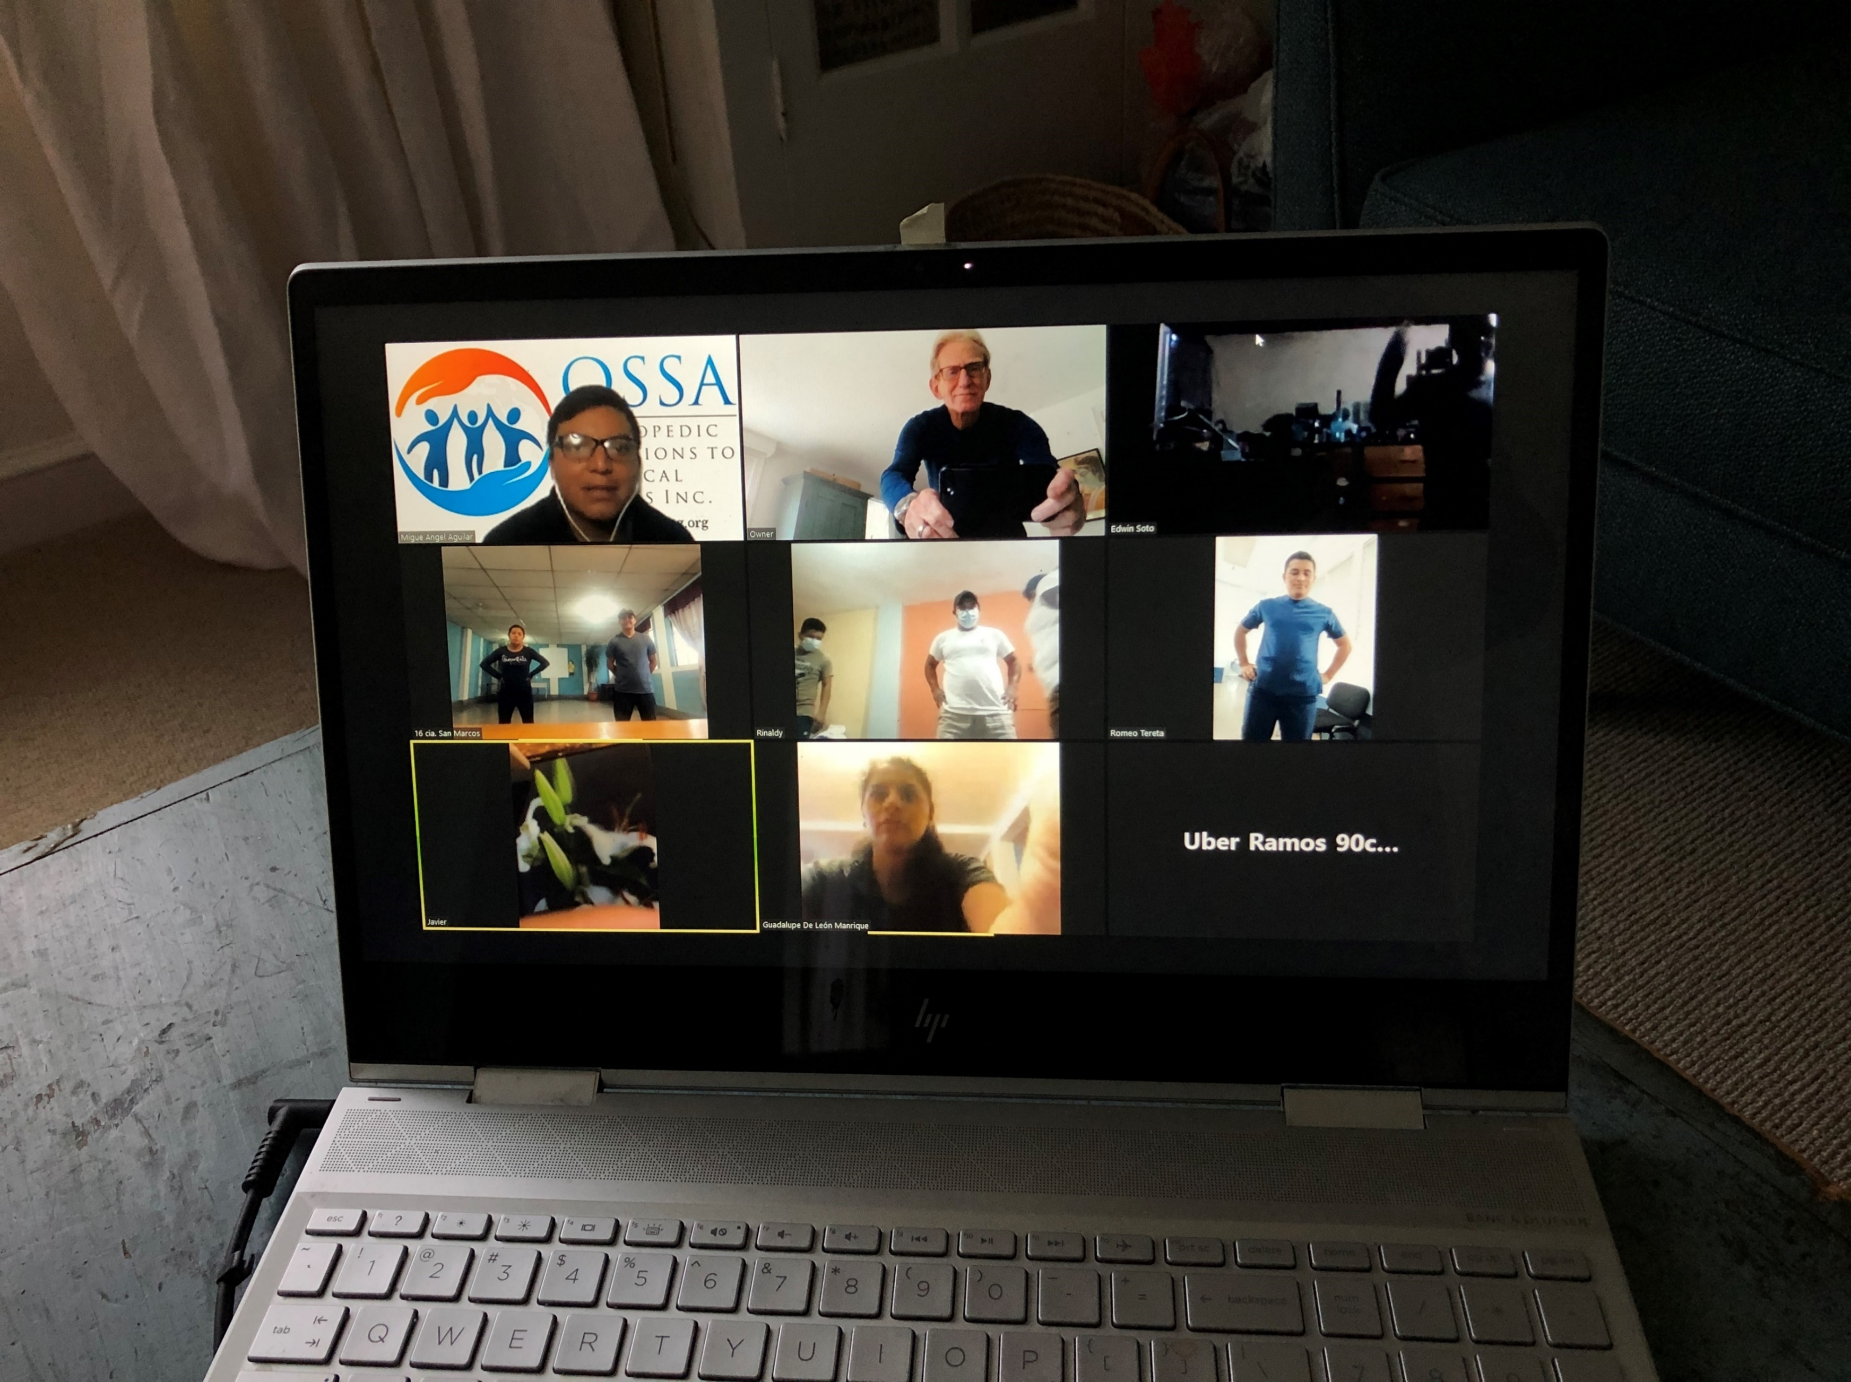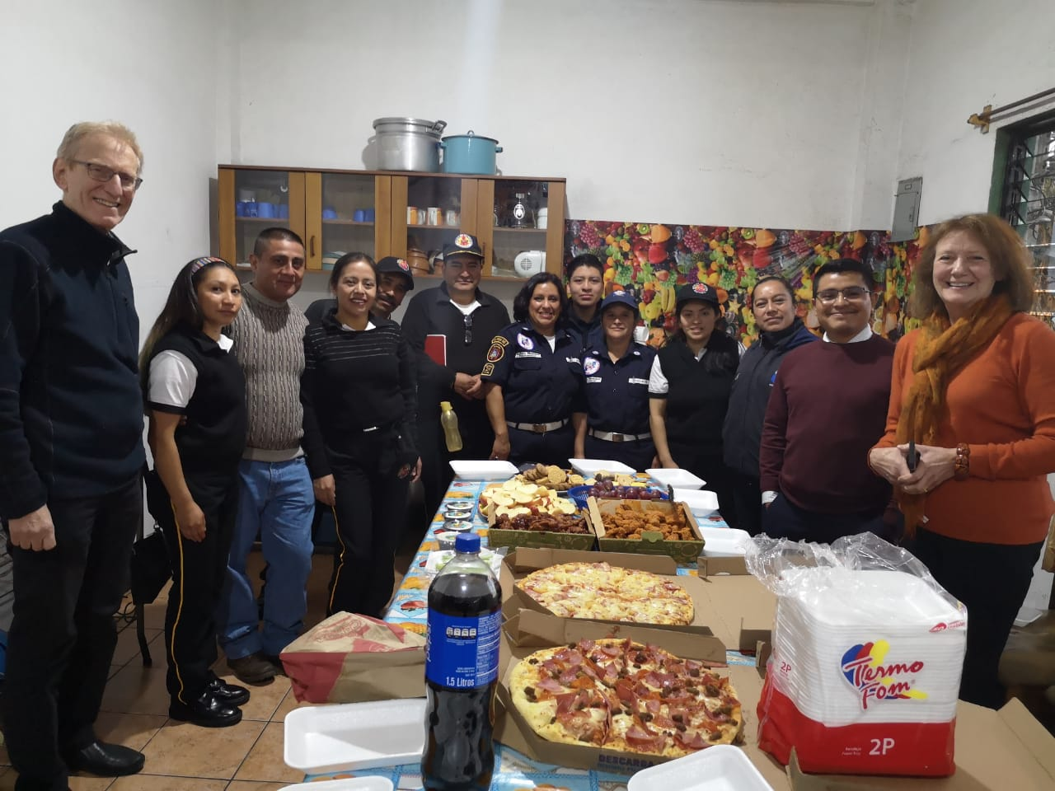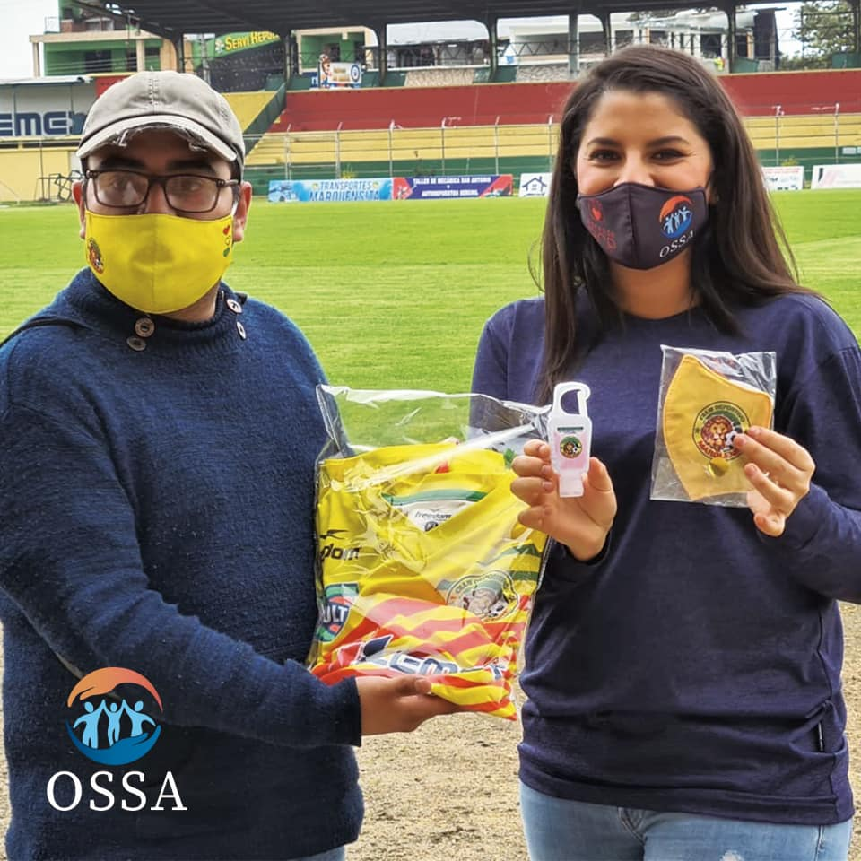
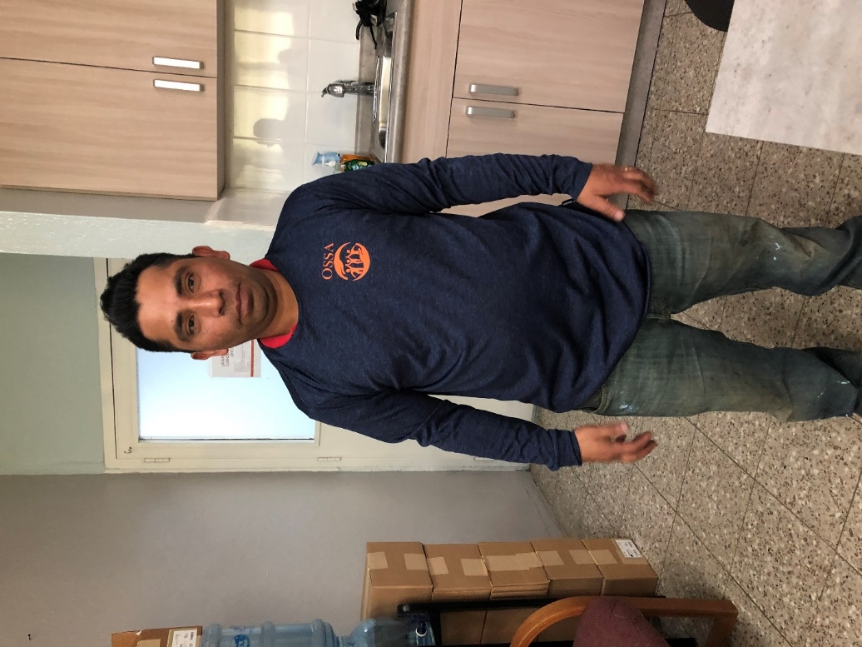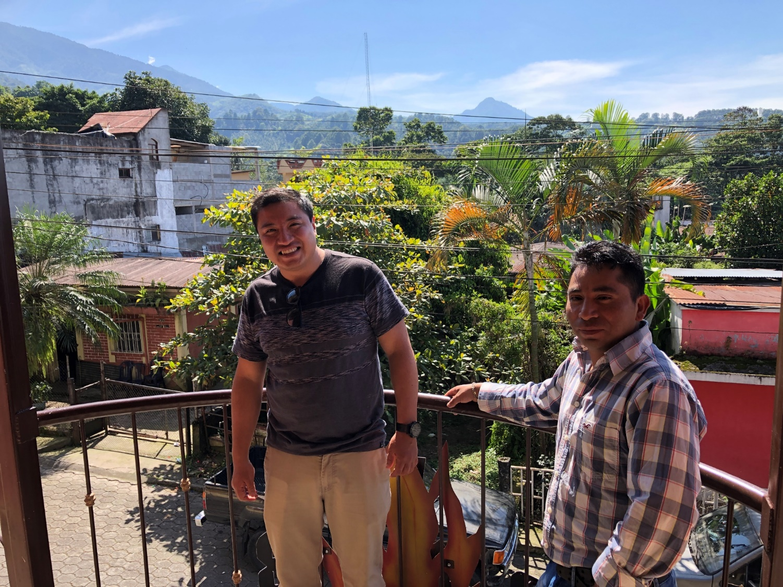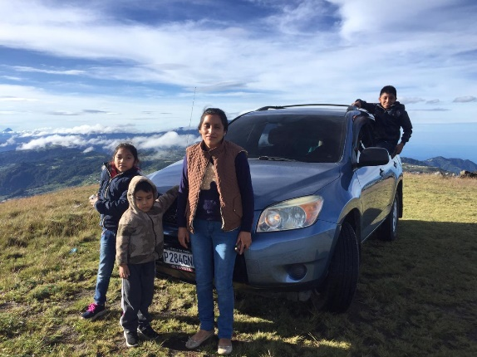
February 2020 -OSSA sponsors 2 Soccer Teams - second division National Soccer League of Guatemala San Marcos Lions (Marquense) and San Pedro Roosters who helped OSSA promote teaching CPR through Game activities including a T-shirt slingshot into the crowds, Facebook postings, OSSA logo on stadium walls. Then OSSA promoted mask wearing and handwashing with water or gels.
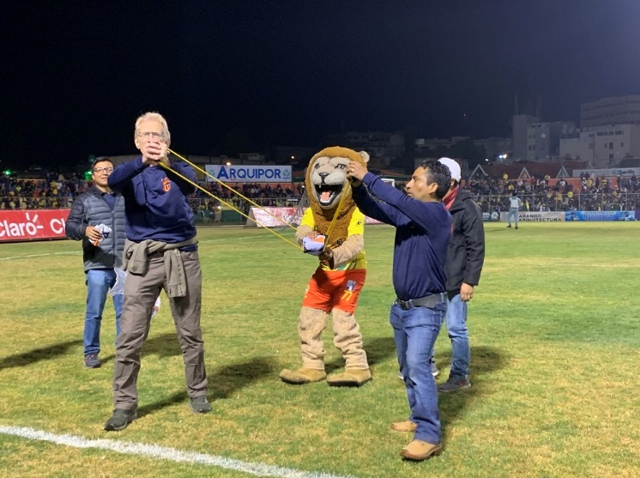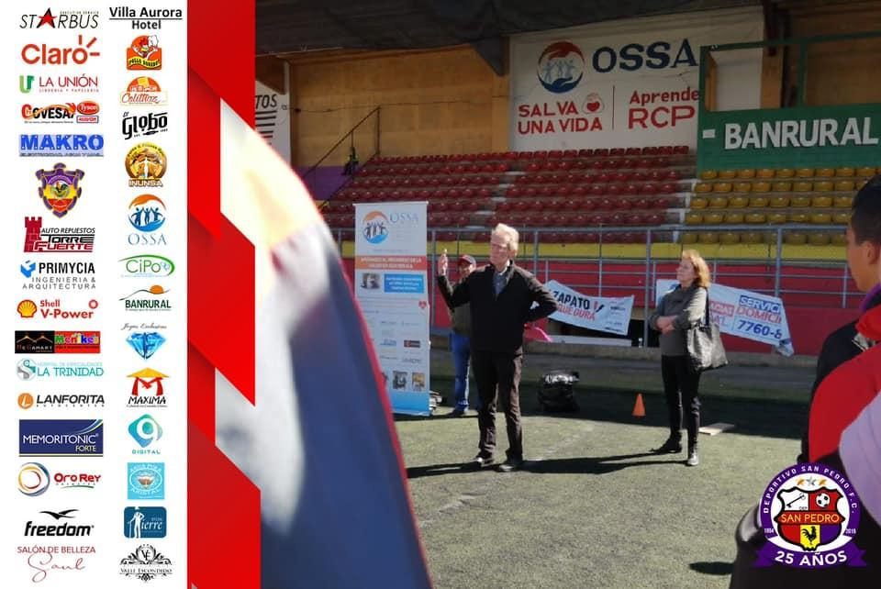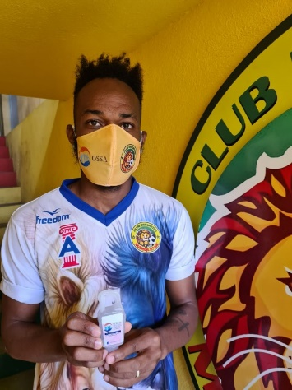

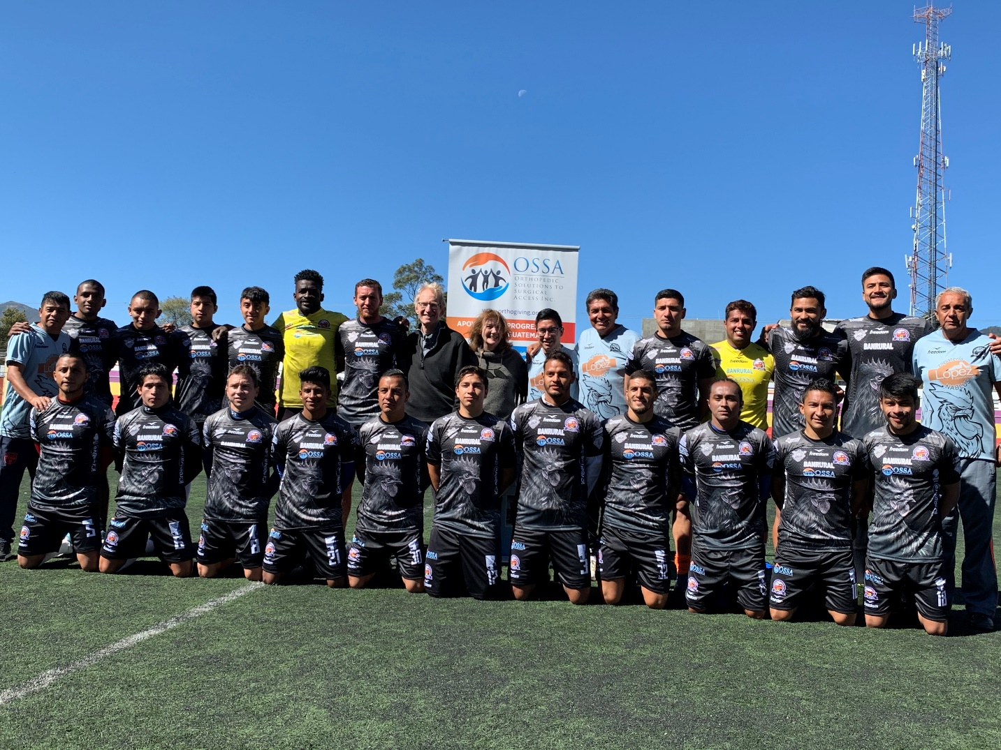
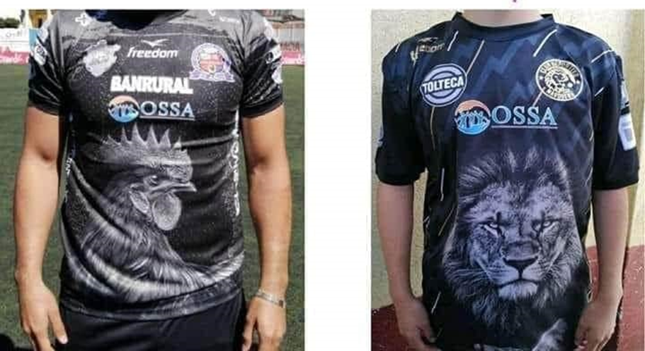
-CPR classes taught by Dr Tereta and Dra. Lupita de Leon., and started a class for CPR instructors
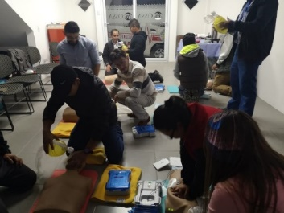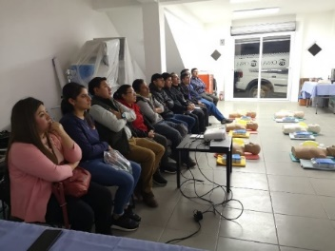

February to April- OSSA sponsored ABOS Orthopedic Education Modules 1-17 for HNSM Trauma Residents as well as other Orthopedic ZOOM talks with Dr Rodrigo Ramazzini from Guatemala City
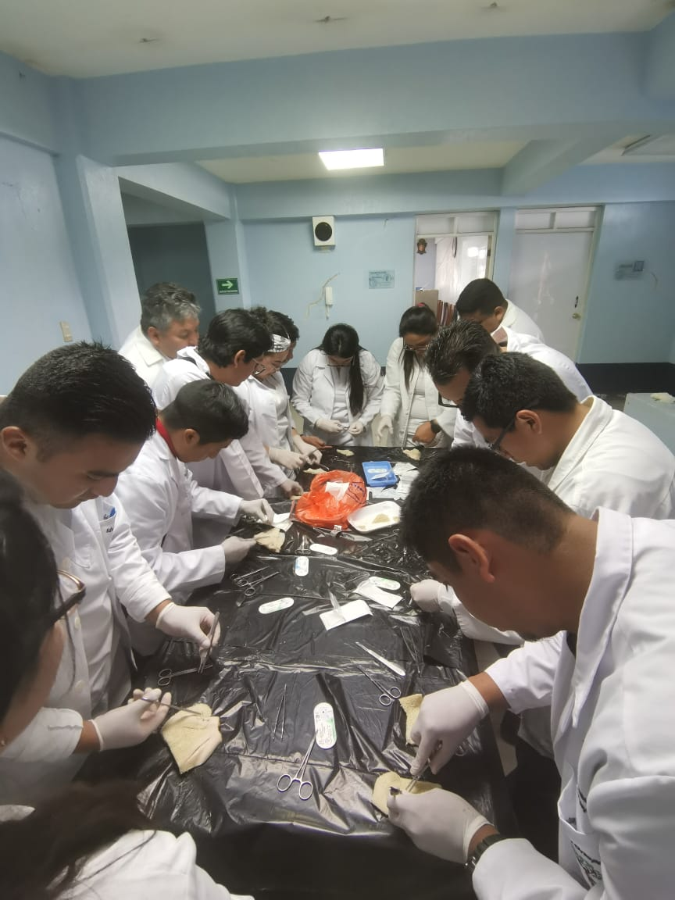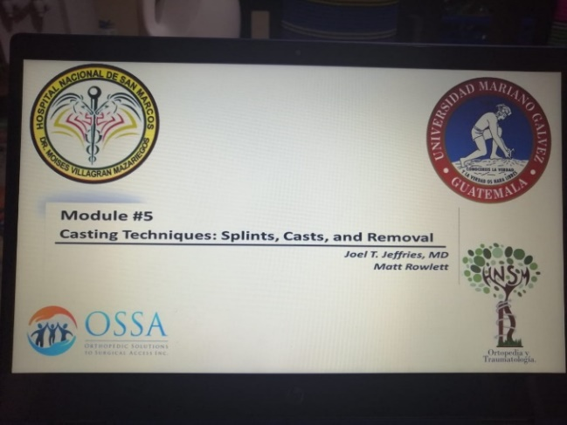
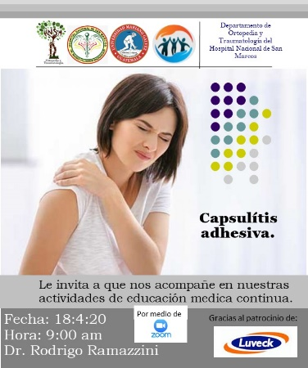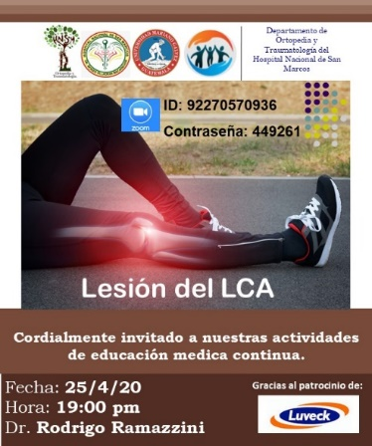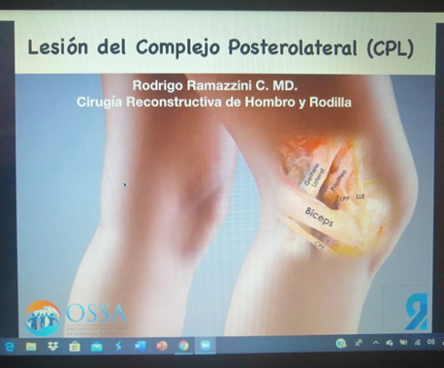
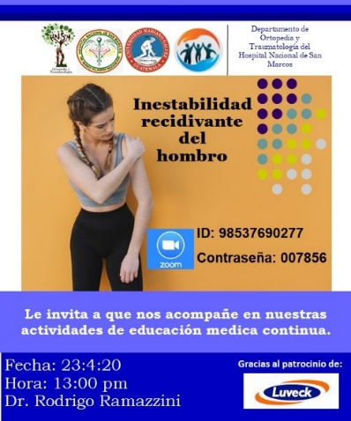 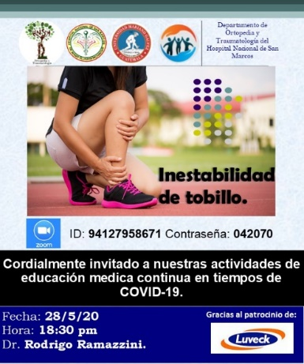 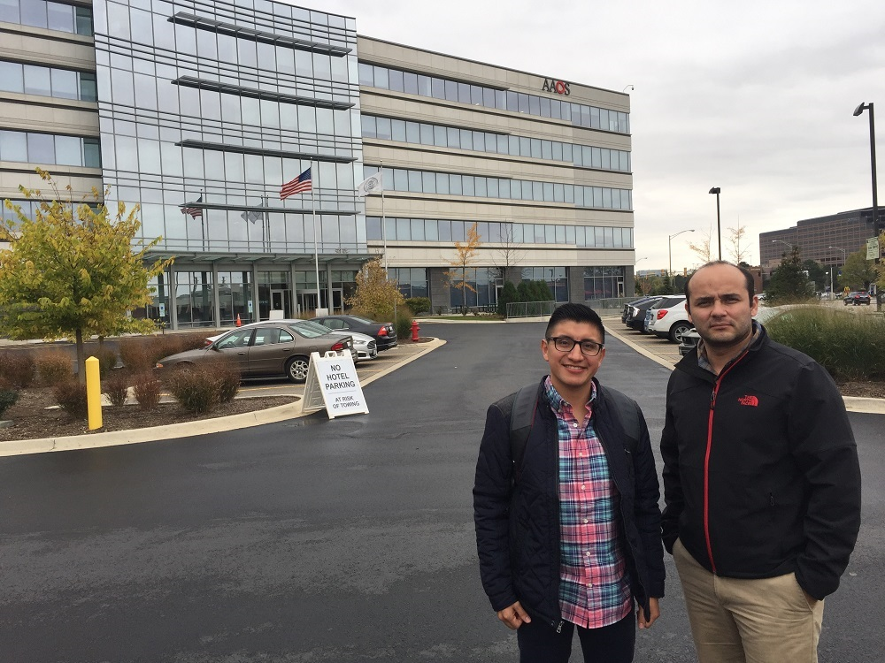 Dr Ramazzini
March 2020- Nursing instruction to Nursing School Galileo University- sterilization/instrument naming and cleaning with HNSM nurses Ingrid Lopez and Norma Amarra, Frisdi Gomez
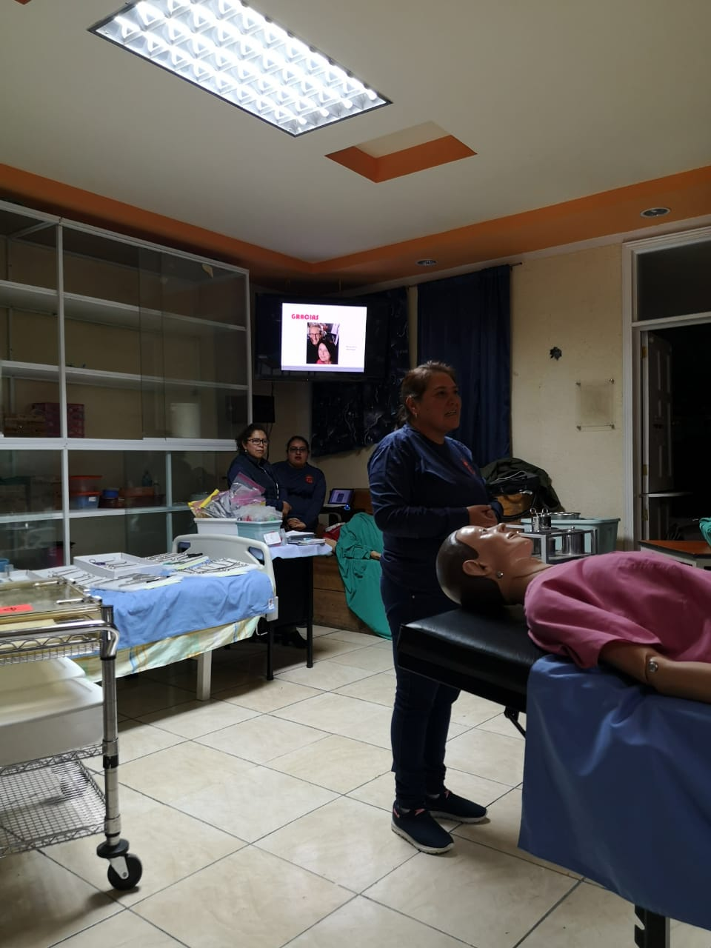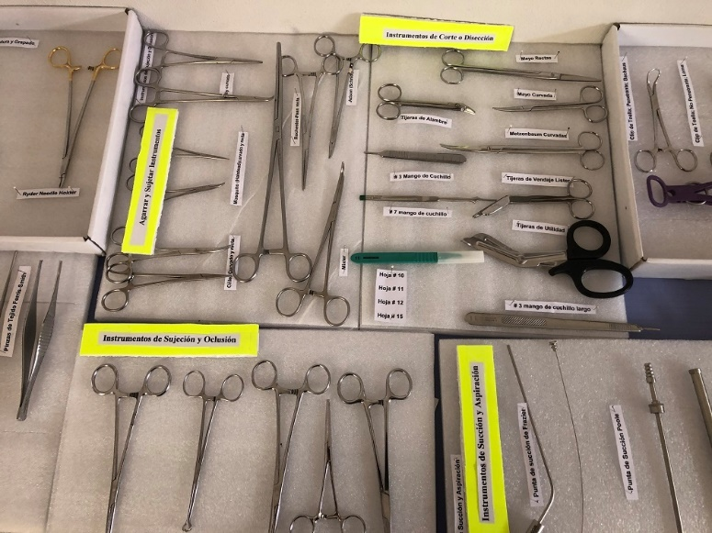
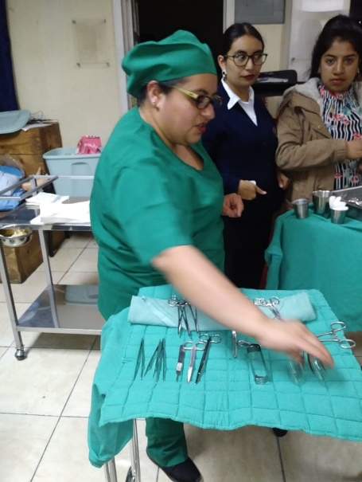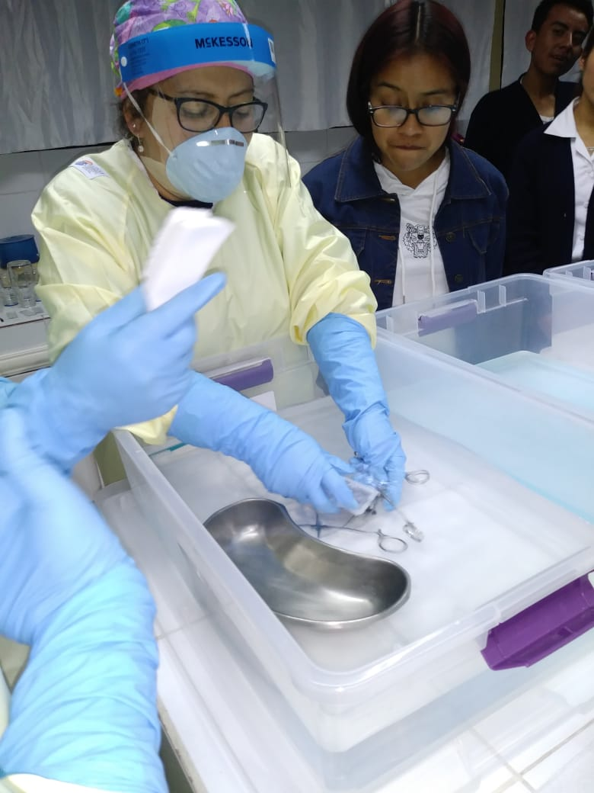
April-August- OSSA provided PPE to HNSM and various private hospitals, firefighters and other healthcare personnel at cost and at times for donation
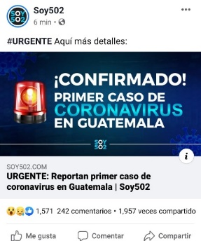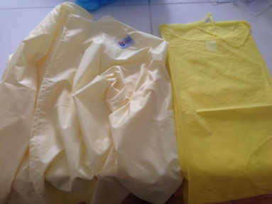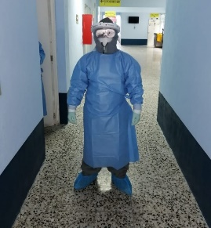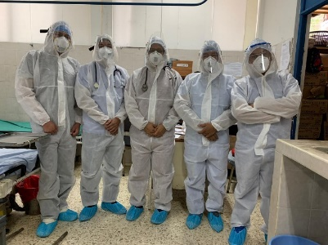
9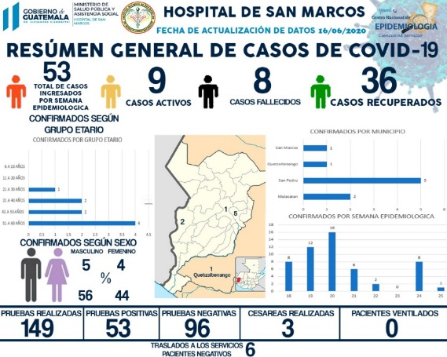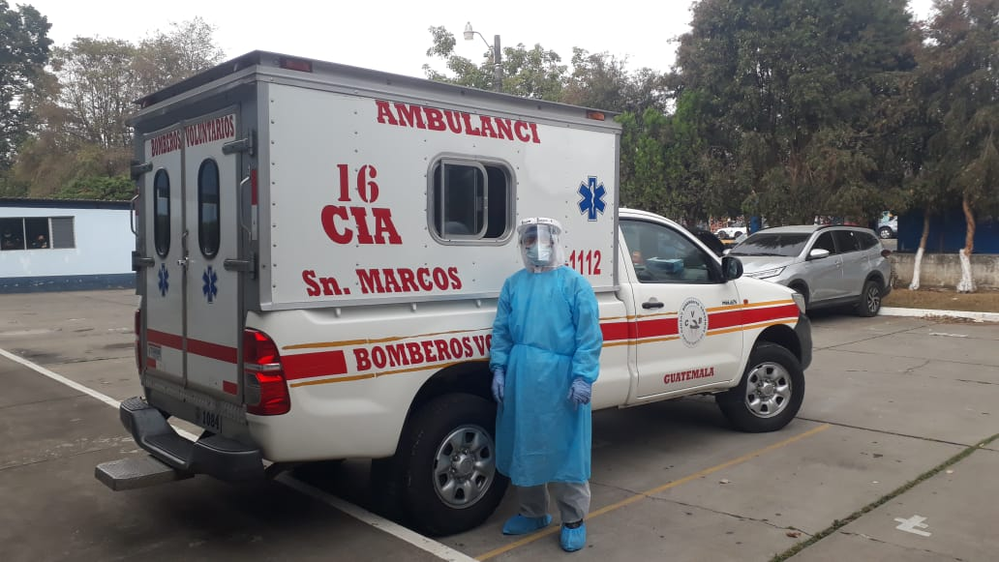
Online OSSA Lecture Series
--June to Sept, Internal Medicine Emergencies multiple weekly lectures
- Nov to Dec, Pre-Hospital Emergencies with International speakers from Mexico and Colombia- twice weekly lectures,
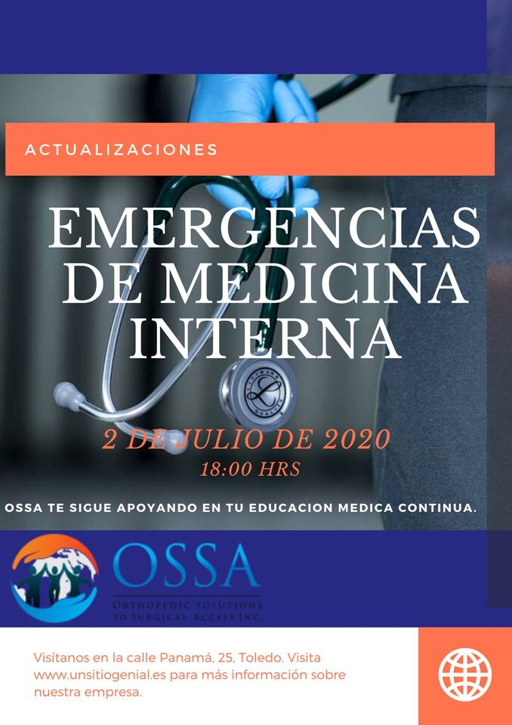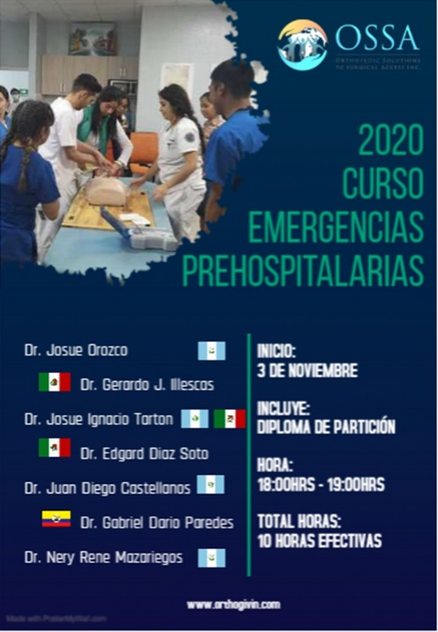
- Nov 2020 began HNSM Trauma Case Reviews with Orthopedic Traumatologist Dr Jack Dawson of Baylor College of Medicine-started

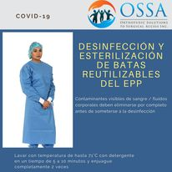
Other public service announcements by OSSA for the Pandemic and CPR
